Contact: Larry Broome, Odyssey Technical Solutions
+1.512.989.7007; Larry.Broome@odysseyrf.com

FOR IMMEDIATE RELEASE

Download photo and text at https://odyssey.repair/QEI-Partners

QEI Partners with Odyssey Technical Solutions for Repair Services of Semiconductor Products
Leader in RF Delivery Systems Teams Up with World Leader in RF Repairs

Round Rock, Texas – May 19, 2021 – Odyssey Technical Solutions, world leader in RF, DC, and microwave repairs, is pleased to announce it has been selected as partners for repair services of all QEI semiconductor products. QEI is a leader in RF delivery systems located in Williamstown, New Jersey, that has made significant gains in the semiconductor market worldwide, after many successful years within the broadcast industry. With a history spanning twenty years and nearly 100,000 successful repairs, Odyssey was the clear choice for partnership with QEI.

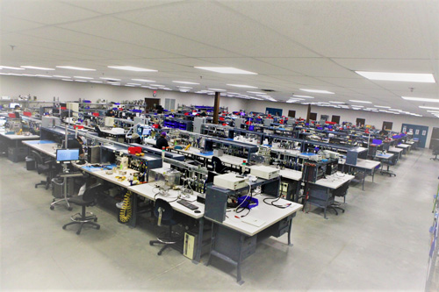
“To support our global systems installed base, we chose Odyssey to be our partners for repair in the US, Europe, and Asia. We, at QEI, believe this first-of-its-kind relationship was the right way to grow and support our critical customers and to meet their expectations. QEI could have chosen to set up service centers worldwide; but we preferred to work with a professional service organization like Odyssey, who could help us achieve an immediate quality repair loop worldwide,” remarked QEI representative, Scott Ivins.

Eric Nail, vice president of Odyssey added, “We are very pleased to align ourselves with QEI; as they gain design wins, we gain repair customers for the future. To establish a relationship between manufacturer and the repair process is smart business for a seamless customer experience. With our locations in Round Rock, Singapore, and our newest in Nijmegen, The Netherlands, Odyssey is well positioned to provide QEI customers the highest quality repair service worldwide.”

For more information about QEI, visit www.qei-rf.com.

For more information about Odyssey Technical Solutions, call +1.512.989.7007, email sales@odysseyrf.com, or visit our website at www.odysseyrf.com.

About Odyssey Technical Solutions

Odyssey Technical Solutions’ technology center is a state-of-the-art repair facility located in Round Rock, Texas. The engineering staff consists of highly skilled professionals working in a meticulously maintained facility, specializing in RF Generators, Automatch Networks, DC Power Supplies, and Microwave Generators / Power Supplies. Odyssey’s reputation for quick turnaround times and customer satisfaction has provided it the opportunity to become involved with an array of different processes and equipment within the industry. The Odyssey team is engaged, motivated, customer focused, and current with the latest advancements in process and equipment engineering. Services include repair, refurbishment, core exchanges, process and equipment engineering, and equipment sales. Odyssey is an ISO 9001:2015 and ANSI/ESD S20.20 Certified company, and a US veteran-owned company.
###
For more information please contact:

Larry Broome
Senior Director of Global Sales and Marketing
Odyssey Technical Solutions
+1.512.989.7007
Larry.Broome@odysseyrf.com

